RESOLUTION NO.__________

RE: CERTIFICATE OF APPROPRIATENESS UNDER THE
PROVISIONS OF THE ACT OF THE PENNSYLVANIA
LEGISLATURE 1961, JUNE 13, P.L. 282 (53
SECTION 8004) AND BETHLEHEM ORDINANCE NO.
3952 AS AMENDED.

The applicant proposes to install storm windows to match trim and trim to be painted the same as the existing at 30 E. Market St.

NOW, THEREFORE, BE IT RESOLVED by the Council of the City of Bethlehem that a Certificate of Appropriateness is hereby granted for the proposal.

Sponsored by: (s)

(s)

ADOPTED BY COUNCIL THIS DAY OF

(s)
President of Council

ATTEST:

(s)
City Clerk

HISTORICAL & ARCHITECTURAL REVIEW BOARD

The applicant proposes to install storm windows to match trim and trim to be painted the same as the existing at 30 E. Market St.

APPLICATION #1:

East Market LLC
20 Cherry Hollow Road
Nashua, NH 03062

OWNER:

__________________________________________________________________________

The Board upon motion by Phil Roeder and seconded by Derrick Clark adopted the proposal that City Council issue a Certificate of Appropriateness for the following:

- To install storm windows on all windows.

2. The meeting rail of the storm windows should align with the height of the existing
window meeting rails.

3. The color to be San Pipe Beige to match the existing exterior trim color.

4. The motion was unanimously approved.

__________________________________________________________________________

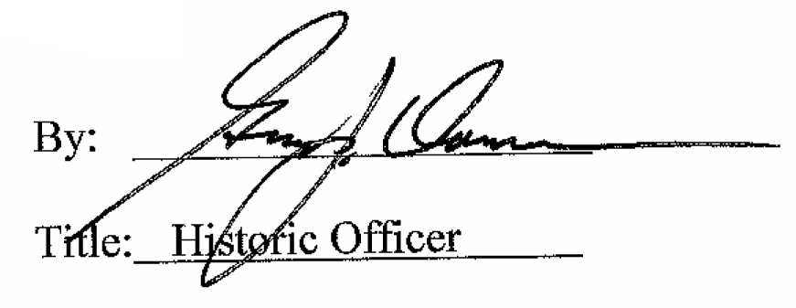

Date of Meeting: June 6, 2018

